Buna dimineaṭa!
English:
SPAG: Present Tense and Past Tense
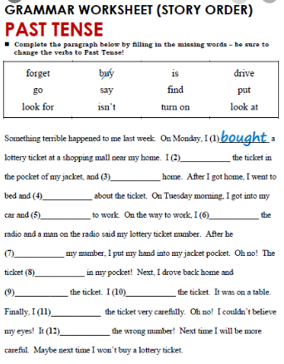
Main:
Task: Look again at your story map, make any changes. With support, act out your story.

Maths: Game time!

Name of game: Subtraction Squares

Learning aim of game: subtracting small numbers

Aim:To create an unbroken line of counters from your starting square to the opposite side of the board.
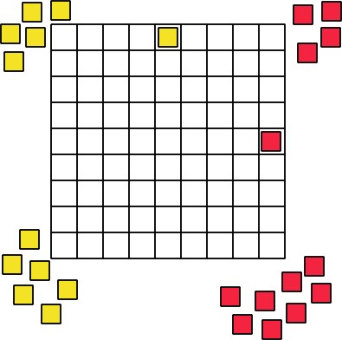

Number of Players: 2

You will need: Copy of the game board below, 2 numbered cubes
About 20 yellow and 20 red counters.

How to Play:
Decide who will go first.
Choose one of the coloured starting squares.
Close to your place, stack the counters that are the same colour as your starting square.
The person with the yellow starting square will travel down the board.
The person with the red starting square will travel across the board.
Take turns throwing the two numbered cubes.
Find the difference between the two numbers showing on the cubes.
Collect the same number of counters of your colour.
Place the counters in a line one next to each other on the board beginning at your starting square.
The line does not need to be straight - you can place the counters to the side of each other.
You cannot skip a square. You cannot move diagonally.
If you come to a counter of the other player's that is blocking your line, you will have to travel around that counter!
The first person to reach the other side with an unbroken line of their counters is the winner.

Choose one of the following:

D&T: Make granny’s house using geometrical shapes. You could use recycled items: fabric, paper, plastic, etc.
https://youtu.be/lUsbK04TdgQ

Art- Watch the video and paint a forest.
https://youtu.be/6WHvmgUXUUE

That’s it for this week. Have a lovely weekend and we will see you next week. Team year 2.

