English – describe a disgusting sandwich using expanded noun phrases
Mrs Grinling needs to think of disgusting fillings for a sandwich so she can keep the birds away. Can you help?

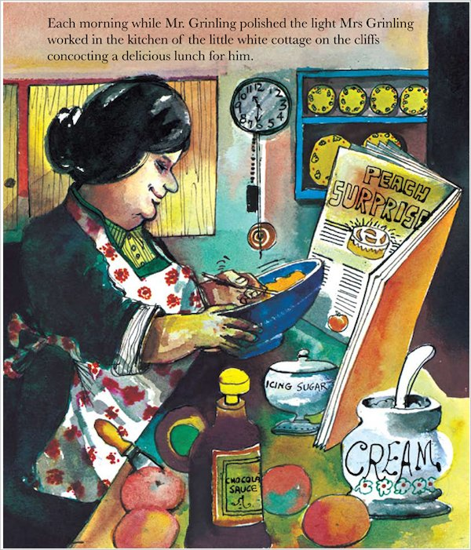
Eg: disgusting, wiggly worms
hairy, poisonous spiders
Maths: To show time on clock faces
Draw these times on the empty clock faces.
1. 7 o’clock 9. Quarter Past 10
2. Half Past 8 10. Quarter to 12
3. Quarter Past 4 11. Half Past 2
4. Quarter To 2 12. 10 o’clock
5. Half Past 3 13. Quarter to 4
6. 5 o’clock 14. Quarter to 7
7. Half Past 6 15. Quarter Past 8
8. 1 o’clock 16. Half Past 5
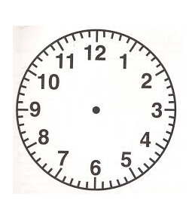

D &T: Make a 3D lighthouse out of household items.
Eg:you can use toilet paper for the base of the lighthouse then paint it or colour it. Draw and cut a circle on a piece of paper then cut it in half. Fold the half to make a cone and put it on top of the lighthouse. Be as creative as possible.
