Name of game: Gotcha
Aim of game: a strategy game
How many players: two players.
You need need: three counters - two the same colour, and a 4 x 4 grid.
(This is a good one to play outside with people instead of counters).
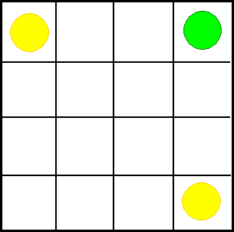
How to play:
Start with the counters in the corners as shown.
Green moves first.
Counters can move one space up, down or sideways.
Yellow is trying to trap Green by getting on either side of it.
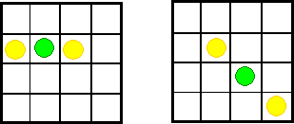

Green trapped!

What strategy does Yellow need to win?
What strategy does Green need to avoid being caught?
Try playing with 2 counters each. Both Yellow and Green can be caught!

