Asteroid Blast

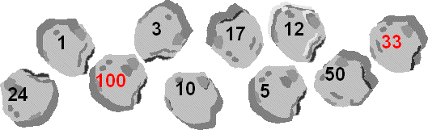
Name of game: Asteroids
Aim of game: To decide which of the four operations to choose to reach target numbers
Number of players: 2+ players. You need 3 dice and a list of 10 target numbers like the ones on those asteroids.
You will need: asteroid sheet/adapted sheet and 3 dice
How to play:
Roll the three dice.
Both players try to make one of the target numbers by using the 3 numbers that come up on the dice, together with whatever operations they like (plus +, minus -, times x, divide ÷).
Both players can blast one asteroid each, but the same asteroid cannot be blasted by both players.
(You might like to set a time limit for each chance to blast - say 2 minutes - before the dice are rolled again).
Once an asteroid has been blasted, that target number is out of the game.
The dice are rolled again for another chance to blast an asteroid.
Play continues until all the asteroids have been blasted. Highest score wins.
Scoring:
•10 points for each blasted asteroid
•5 bonus points for blasting 100 or 33
•3 bonus points for using division
•2 bonus points for blasting an even number (except 100)

