Answers
English
SPAG: Present Tense-Questions
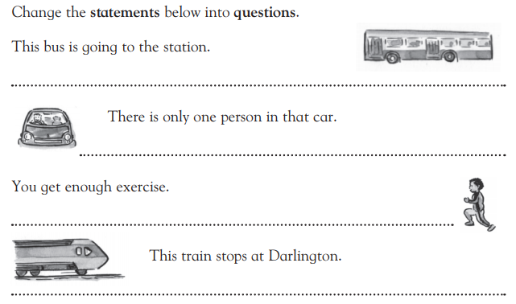
Does the train stop at Darlington?
Do I get enough exercise?
How many persons are in that car?
Where is the bus going?
Main:
Task: Answer comprehension questions.
- Who was covered in spots?
Auntie Rosie was covered in spots.
- Did Little Red walk under the sleepy crocodiles?
No, she walked over the sleepy crocodiles.
- Who gave Little Red a lift?
She caught a lift on an elephant.
- What did the lion do with Auntie Rosie?
The lion plonked Auntie Rosie in a cupboard.
- Did Little Red realise that it wasn’t Auntie Rosie sitting in the bed?
Yes, she did, straight away.
- What did Little Red do with the lion’s hair? Why?
The Little Red brushed, combed and twisted and braided until the lion had a lovely new look. She wanted to give him a lesson.
- What would you do if things didn’t go according to plan?
I would think of different ways to solve the problem in a nice and friendly manner.
- What have you learnt from this story?
I have learnt that if you need anything, all you need to do is just to ask nicely for it.

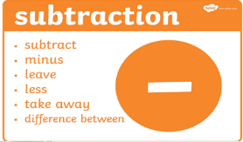
Maths: Column subtraction (with exchange for task 3)
Watch Mr Davies’ video again. (no exchange) https://youtu.be/OVQat6orWjA?list=PLxyUJEC5mlQ6Qwj3GeAccBtIUTR1TcdII
Watch this video to help you solve two digit subtraction sums with exchange.
https://youtu.be/PP9N7RQAO0w
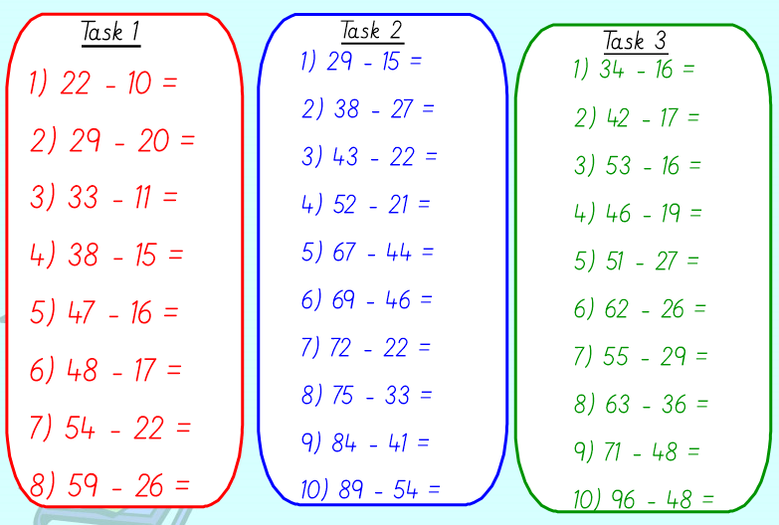
48
23
27
26
36
24
27
37
25
18
35
43
42
50
23
23
31
21
11
14
31
32
33
31
232
222
92
12

