Answers

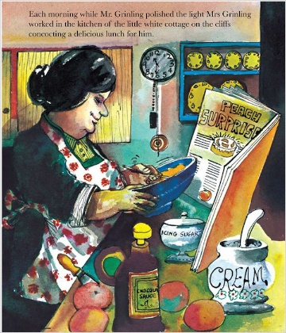
English – describe a disgusting sandwich

Eg: disgusting, wiggly worms
hairy, poisonous spiders
slimy, wet ham
mouldy bread
stinky, gooey cheese
sticky, yucky slugs
drippy, smelly sauce
cockroach powder
googly caterpillar eyes
Maths:
Draw these times on the empty clock faces.
1. 7 o’clock 9. Quarter Past 10
2. Half Past 8 10. Quarter to 12
3. Quarter Past 4 11. Half Past 2
4. Quarter To 2 12. 10 o’clock
5. Half Past 3 13. Quarter to 4
6. 5 o’clock 14. Quarter to 7
7. Half Past 6 15. Quarter Past 8
8. 1 o’clock 16. Half Past 5
