Answers

English
SPAG:
Task: Fill in the gaps with the correct form of the verb.
1 My father reads two newspapers every day.
2 I visit my primary teacher on every teacher’s day.
3 My uncle usually drinks two glasses of juice after dinner.
4 My mother is always a careful driver.
5 My father has always a bath in the mornings.
Maths
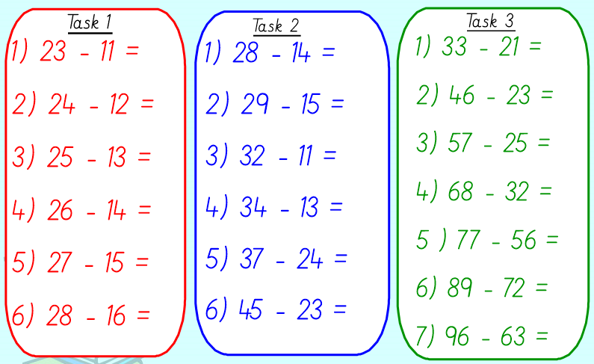
33
17
21
36
32
23
12
22
13
21
21
14
14
12
12
12
12
12
12

Spanish: Food
Task: Write down some of the food you like (me gustan) and dislike ( no me gustan).
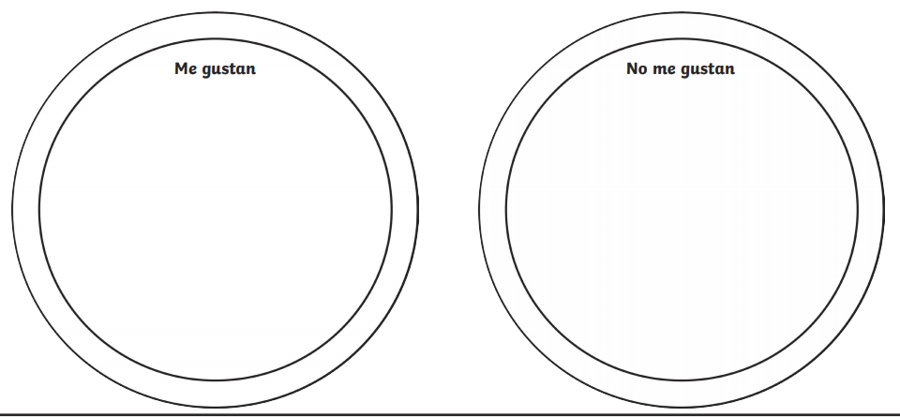
La manzana, las zanahorias, los chichaors, el techuga, el pan
La carne, el tomato, la pera, el pescado, los huevos ,el pollo
That’s it for today. See you all tomorrow. Team year 2

