Tac-tickle

This is a challenging game of strategy for two players with many interesting variations

RULES FOR THE `PURE TAC'
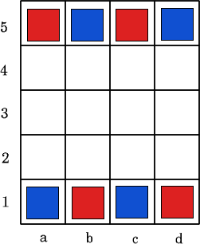
The game starts with the 4 red and 4 blue pieces arranged on a 4 by 5 board as shown.
- We call the players RED and BLUE, and RED moves only red pieces, BLUE moves only blue pieces.
- A move consists of moving one piece to an adjacent empty square, up, down or sideways but not diagonally. There is no jumping or capturing in this game.
- The objective is to get 3 pieces in a line, vertically, horizontally or diagonally with no empty spaces intervening. The first player to get 3 in a line wins.

