Bonjour !
English:
SPAG: Past Tense –Questions
We use ‘did’ and the verb to make questions. Don’t change the verb to the past form. We also use lots of question words like: where, what, why, when, how, when.
Eg: Did you have a nice weekend?
What did you learn at school yesterday?
Did you have fun with your friends?
Where did you go for your last holiday?
The verb ‘to be’ doesn’t need ‘did’ to make questions.
Eg: Where were you yesterday?
Was he late for work?
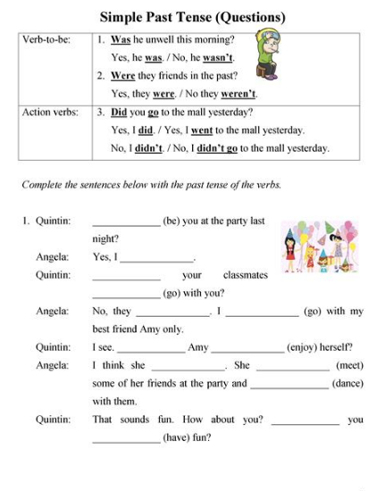
Main:
Task: Plan your own version of Little Red Riding Hood as a story map.
You might want to take into consideration the following questions:
Who will be the main character?
Where will it be set? (city, dessert, arctic)
Who will be the character that tries to eat your character up?
How will your main character overcome your character?
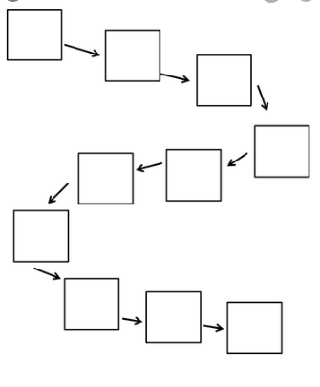
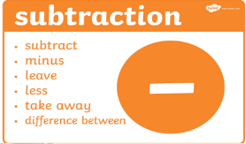
Maths: Column subtraction (with exchange for all tasks)
Watch this video to help you solve two digit subtraction sums with exchange.
https://youtu.be/PP9N7RQAO0w
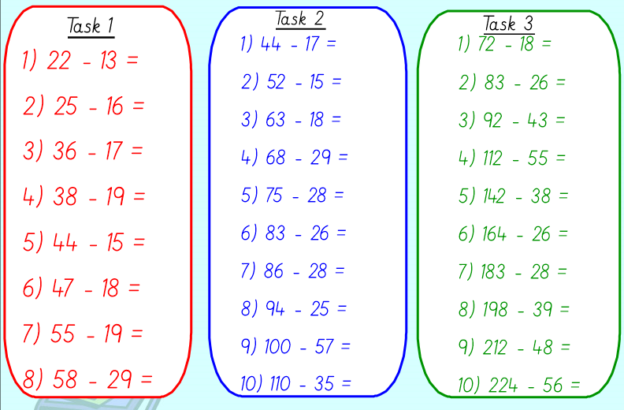

History: Neil Armstrong. Go through the slides of the PowerPoint Presentation. Following yesterday’s work, today we will be answering a question.
PowerPoint Presentation
Task: If you were travelling to the moon, what would you take and why?
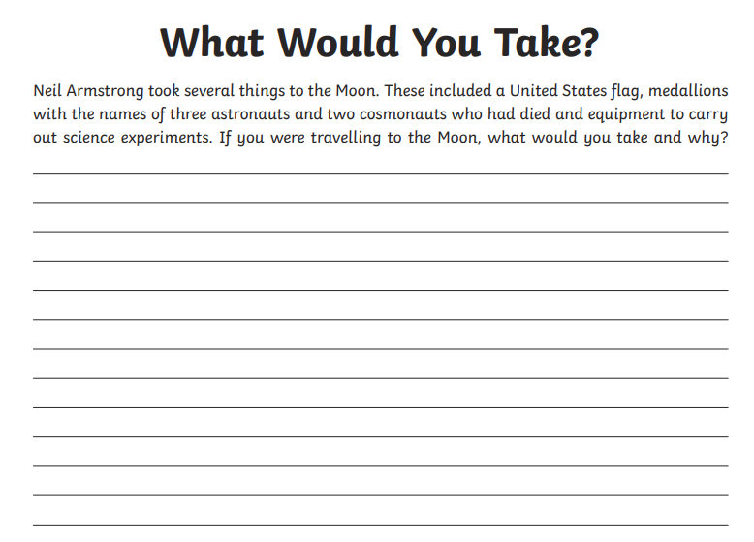
That’s it for today.
See you all tomorrow! Team year 2.

