Answers
English:
SPAG: Past Tense –Questions
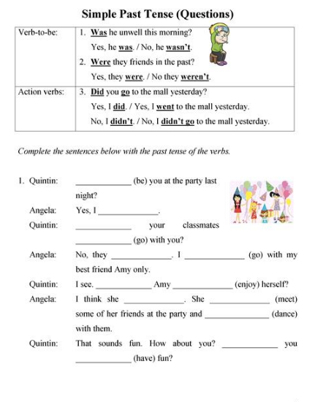
have
Did
danced
met
did
enjoy
Did
went
didn’t
Were
was
Did
go
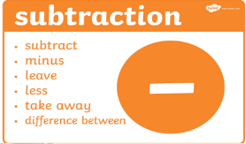
Maths: Column subtraction (with exchange for all tasks)
Watch this video to help you solve two digit subtraction sums with exchange.
https://youtu.be/PP9N7RQAO0w
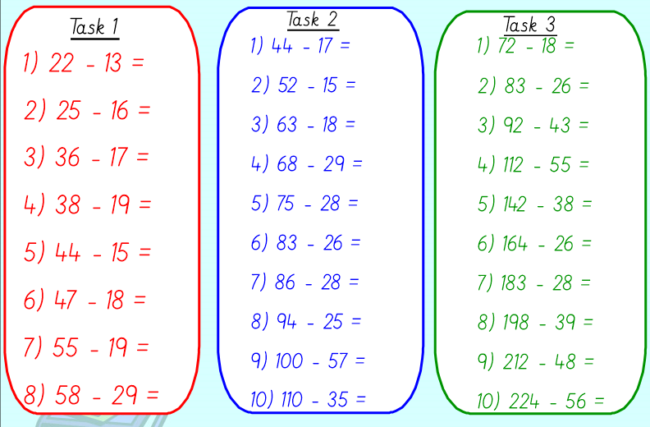
57
104
138
155
159
49
164
168
45
57
39
47
57
58
69
43
75
54
37
27
29
19
19
29
36
29
9
9

