Hi everyone in Year 2,
We hope you’re ready to take off on another adventure with Baby Bear and zoom into his world of imagination!
Get active with ‘The Body Coach’ at https://www.thebodycoach.com/blog/pe-with-joe-1254.html
Literacy (1 hour):
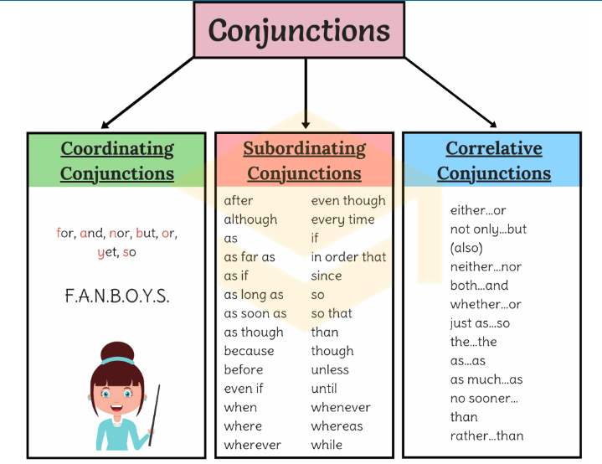
SPAG: Conjunctions: Conjunctions are words used to connect phrases, words, or clauses. The poster below shows the 3 main types of conjunctions (it’s a good resource to keep, so save or print it off for future reference and revision, if you’re able to)

Use these conjunctions to fill the gaps in the sentences below:
- I went to the park __ played on the swings.
- I didn’t finish my dinner __ I wasn’t allowed to have pudding.
- My sister was upset ____ she lost her favourite teddy.
- I really wanted to go to the fairground ride ___ I was too small.
- My mum said I could go to my friend’s house ___ I finished my homework.
Main: Comprehension
Re-watch ‘Whatever Next’ by Jill Murphy. https://www.youtube.com/watch?v=Nn73STXrPP0
Answer these comprehension questions about the story. Remember to use ‘because’ to explain your answers.
- Where did Baby Bear want to go?
- Why did Mummy Bear tell Baby Bear he couldn’t go?
- What did Baby Bear find in the cupboard under the stairs?
- Where did Baby Bear find the space helmet and space boots?
- Write 3 more items Baby Bear could’ve packed for his journey.
- What did Owl say to Baby Bear when he flew past him?
- When they landed on the moon, why do you think Owl noticed that there were no trees?
- When Baby Bear had to go home, why did it rain through his helmet?
- Why was Mummy Bear shocked when she saw Baby Bear?
- Do you think that Mummy Bear believed Baby Bear’s story? Why or why not?
Numeracy: Column Addition: Choose a task and complete the tasks that you are comfortable with. 2 and 3 digit addition (without exchange)
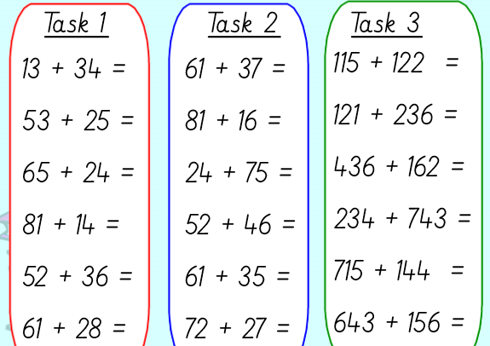
Extension: Create 5 of your own column addition sums.
D&T – Designing a Rocket
Design and label a rocket for your Baby Bear so he can travel up to space in style!
Think about:
- the shape of your rocket
- How big it needs to be for Baby Bear and things he needs to carry in it.
- A logo and colours.
- The shape of the windows and doors.

Collect some junk modelling around your house for Wednesday so that you can make your rocket. This can be empty kitchen roll, empty tissue box, coloured paper, cereal boxes, milk bottles etc. You may also need glue or sticky-tape.
Hope everyone had a great day, answers tomorrow. And remember to check out our ‘Useful websites’ button for more learning opportunities. See you later, alligators!!
Team Year 2

