## **two-acorn-oak-leaves-cartoon-illustrations-44997062 two-acorn-oak-leaves-cartoon-illustrations-44997062**

## **Danegrove School**

*Secure, Self-Confident, Successful*

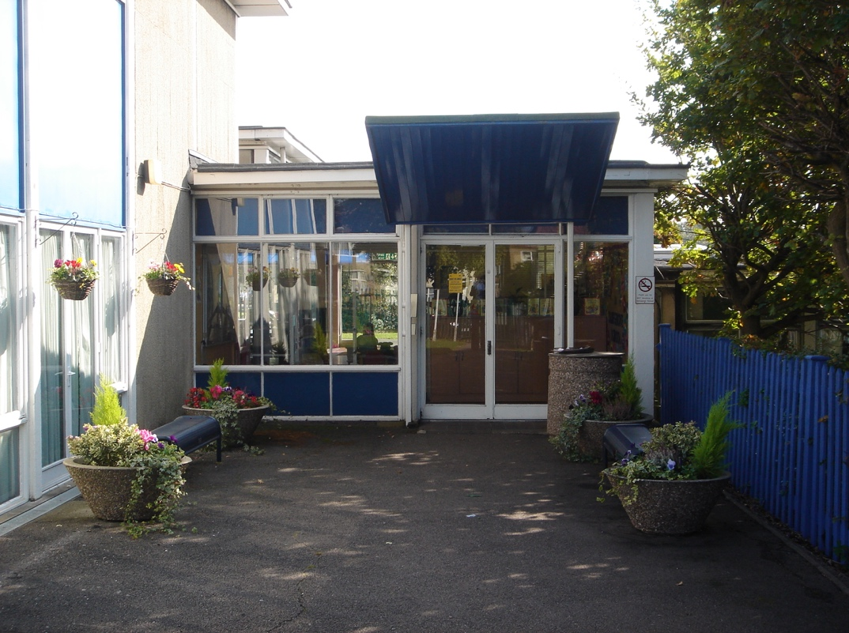

**Foundation to Yr 1**

Ridgeway Avenue

East Barnet

Herts

EN4 8TN

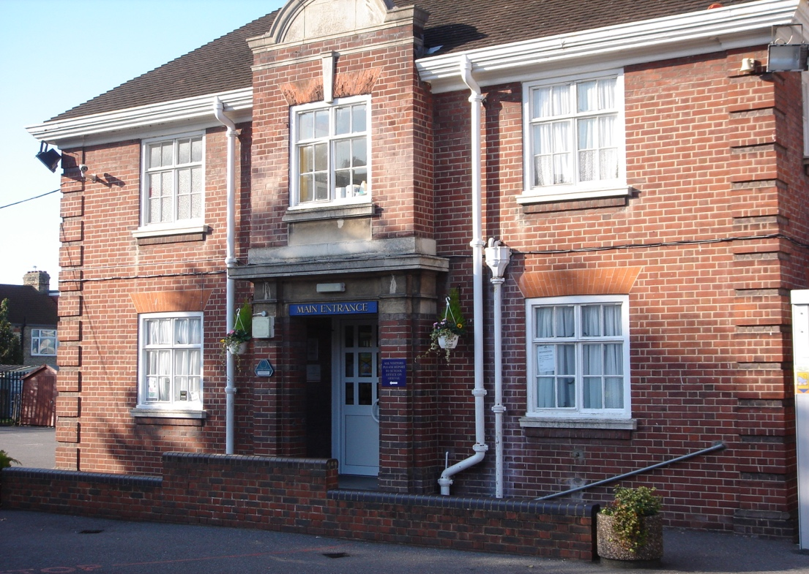

**Yr 2 – Yr 6**

Windsor Drive

East Barnet

Herts

EN4 8UD

## **School Prospectus**

Dear Parents, Children and Friends,

Welcome to Danegrove Primary School

On behalf of myself, the staff, governors and pupils, can I warmly welcome you to Danegrove Primary School.

Danegrove is a mainstream Primary School that is committed to inclusive education and meeting the needs of all the children in its care.

We aim to provide a lively, creative curriculum to challenge and motivate our pupils and enable them to participate in a range of high quality learning opportunities. The schools excellent facilities enable an excellent standard of education. We had a new year 2 unit built in 2013, and this has enhanced the opportunities that we can provide our children (although we are always seeking to make them even better).  However, our greatest resource is our skilled and dedicated staff who work tirelessly to provide the best teaching and learning experience for each child.

We want our pupils to enjoy coming to school and to be enthusiastic about learning. We will nurture and encourage pupils and hopefully, inspire them to be active participants in their own development and education.

We encourage our pupils to be responsible and thoughtful and play an active part in all aspects of school life. Our School Council gives the children a voice where their thoughts and ideas can be expressed and put into practice.  We want our children to feel safe and secure and have the confidence to achieve their full potential both academically and personally.

Our ethos is built on mutual respect for others, their values and belief. We hope to develop positive, active learners who are prepared for their role in a rich and diverse society.

At Danegrove we pride ourselves in our strong home/school relationships. We encourage an open door policy, allowing parents and staff to meet whenever a need arises. We hold a weekly Parents' surgery where parents and carers can meet  a school leader to discuss any worries, concerns or queries.  We place high value on establishing close links between home and the school so that we can effectively work together to achieve the best for your child.

We expect high standards of behaviour from all of our pupils, and ask parents to enter into a Home-School Agreement with us, which sets out how the school and parents can work together.

We are passionately committed to individual achievement, personal growth and the pursuit of excellence for every child.

We hope Danegrove Primary School enjoys a long and successful working relationship with you and your child.



Deborah Metcalf

Headteacher

**Danegrove School - General Information**

**Foundation & Yr 1**

Ridgeway Avenue

East Barnet

Herts. EN4 8TN

Tel: 020 8449 4024

Fax: 020 8441 9270

**Yrs 2 – 6**

Windsor Drive

East Barnet

Herts. EN4 8UD

Tel: 020 8449 4024

E-Mail: [office@danegrove.barnetmail.net](mailto:office@danegrove.barnetmail.net)

Deputy Headteachers: Mr. Huseyin and Mr. Davis

Headteacher: Mrs. D. Metcalf

Chair of Governors: Mrs. L. Gowling

\_\_\_\_\_\_\_\_\_\_\_\_\_\_\_\_\_\_\_\_\_\_\_\_\_\_\_\_\_\_\_\_\_\_\_\_\_\_\_\_\_\_\_\_\_\_\_\_\_\_\_\_\_\_\_\_\_\_\_\_\_\_\_\_\_\_\_\_\_\_\_\_\_\_\_\_\_\_\_\_\_\_\_\_\_\_

###### Times of the school day

**Ridgeway Avenue Windsor Drive**

9.10am – 3.15pm 8.55am – 3.30pm

Lunch: 12 noon – 1.00pm Lunch: Staggered between 11.45 & 1.15pm

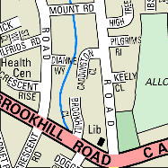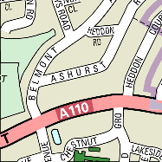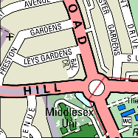

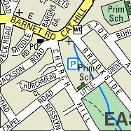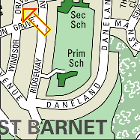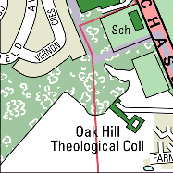

Our Mission Statement

**We aim to help children become secure, self-confident and successful.**

At Danegrove School great emphasis is placed on developing a growing sense of self-esteem and respect for others. Everyone at Danegrove is encouraged to develop a collective respect for his or her school. We aim to give equal opportunity to all, regardless of gender, race or religion. Our policy is to prepare pupils to live and work harmoniously together.

**Our School**

Danegrove is a three-form entry County Primary School. It is set in a very attractive environment on the margin of London’s Green Belt. The school has two sites; children enter school in the Foundation Stage on the Ridgeway Avenue site. They stay on that site for two years, moving on to the Windsor Drive site for years 2-6. Each year has three classes with 630 pupils on roll in September 2019.

The school is able to offer outstanding facilities for its pupils on both sites, including well-equipped, spacious classrooms and libraries. There is a Music Room, a Special Needs Resource Unit and group teaching rooms. Each class has its own computer system and has access to the Computer Network Room, Ipads enhancing research skills.

**Safeguarding/Child Protection**

**The welfare of our children and their safety is the overriding consideration of the school at all times.  As with all schools, we have a legal duty to look out for signs of abuse in children and report any concerns to the Social Services at the Local Authority, who will carry out the necessary investigations.  We follow the procedures and guidelines set out in the London Child Protection Procedures.**

Danegrove School is committed to safeguarding and promoting the welfare of children and young people. All appointments are subject to two satisfactory references and a satisfactory enhanced DBS check.

The Safeguarding Team are:

Deborah Metcalf (Headteacher), Huseyin Huseyin, Nick Davis (Deputy Headteachers) and Kristel Stevens (Learning Mentor).

   

The Lead Designated Teacher for Child Protection is Deborah Metcalf.  She has received Level 3 training for this role, and regularly attends further courses.

The Deputy Headteachers, Huseyin Huseyin and Nick Davis are Designated Teacher and have had level 3 training.

The Designated Teachers report to the Senior Management Team and the Staffing and Pupil Welfare Governor sub-committee.

Janet Mead is the safeguarding governor (also fully trained.

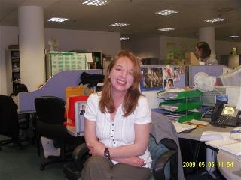

All staff receive appropriate initial child protection training and regular updating, as well as being supervised and supported in the work they do.  All staff and some Governors received updated training in June 2019.  Information is available on how to obtain advice, support and help if there is a concern that a child is being harmed in any way.

Danegrove School follows Safer Recruitment of staff procedures.  Interview panels always include members who have completed Safer Recruitment training.  All staff are required to complete an enhanced DBS (Disclosure and Barring Service) check before they can work in the school.

The school maintains a single central record that contains all of the data required by Ofsted.

All adults should be aware of the DfE booklet: Keeping Children Safe in Education

Further information about safeguarding children in Barnet can be found on the Barnet Safeguarding Children Board website: <http://www.barnet.gov.uk/bscb/>

Danegrove School has a range of policies and procedures for paid and voluntary staff to ensure the safety and well-being of children and young people.  Please see the policy section of the website.

The responsibility for introducing, implementing, and maintaining the Safeguarding Policy rests with the Governors.   They formally review the policies in line with the monitoring review system.

The Headteacher, Deputies, SENCO and Learning Mentor meet every Tuesday morning to discuss children currently facing difficulties and who may benefit from some extra support or attention. The care of children and adults in the Danegrove community is an important part of every day.  Our aim is to provide a supportive and friendly atmosphere for all our families and children to help them achieve their potential.

If there is a problem, your first point of contact should usually be your child’s class teacher.  They will often be able to reassure you that the problem was dealt with appropriately, or support you with a concern.  They are available in the playground most days for a quick word after school, or if it is a longer or more personal matter please make an appointment to see them.

Alternatively, or if you wish to discuss the matter further, you could speak to our Learning Mentor.  We provide support for families and children who are facing difficulties, and work to promote effective participation in school life. Please report each concern or worry you may have to school staff rather than addressing other parents. The Deputy Headteachers run a weekly ‘Surgery’ Friday mornings

9 -10am at Windsor Drive for any parent to attend without an appointment.

**Joanne Campion** is our Special Needs Co-ordinator and a member of the Leadership Team.  Mrs Campion teaches individuals and small groups of children who need extra support, and is the line manager for our teaching assistants, who work with pupils with special educational needs. She is available to support parents who have concerns about their child’s progress.



**Susan Shepherd and Wendy Wilson** are our Pupil Welfare Officers on Windsor Drive.  They have worked at Danegrove for some 18 and 10 years respectively and look after the medical and first aid needs of all the children in the school; as well as providing emotional support to children.

** 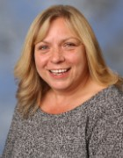 **

Tosh Murat is our Pupil Welfare Office on Ridgeway Avenue.

**Kristel Stevens is** our Learning Mentor.  Her role is to support children in overcoming barriers to learning and helps to enhance their emotional wellbeing.  Mrs Stevens works with children individually, in small groups and with whole classes to build confidence and self-esteem. She offers support and organise activities in the playground at playtime and lunchtimes.



**Julia Stokes** deals with all attendance matters and is responsible for contacting parents when children are absent.

The school takes Child Protection and Safeguarding extremely seriously.

We continually review our practice to make sure that our children are safe, not only at school but also on their journeys to and from school and as far as possible at home.

All reports are investigated and any concerns addressed and where required reported to the Local Authority.

#### School Council

The School Council meets every week usually on Friday at lunchtime. Meetings last about half an hour.  Classes also hold their own class council meeting to discuss items for the next full Council meeting. If you have something you would like us to discuss at School Council please tell your class representative.  Each class has two school representatives, usually a boy and a girl, although this is not always the case. It is up to each class to vote for their representatives. The reception children will join the school council for the first meeting of the summer term.

The School Council is led by Mr. Davis and Mr. Huseyin (Deputy Headteachers).

**Staffing**

Each class of pupils is taught by a range of our teachers and teaching assistants across the week.

We have teachers who specialise in teaching Music, Spanish, ICT, PE and RE, in particular.

Teachers are required by law to prepare, plan and assess (PPA) their classes are covered by our PPA team during those sessions.

We also have a number of job-shares. We actively promote retention of our teachers by allowing part time working. The children, we find, benefit from a job-share – a wider range of teaching skills and enthusiasm.

**Finance**

The annual budget is prepared by the Chair of Finance Governors’ Committee, the Bursar, Headteacher and Deputy Headteachers.

**The Curriculum**

*We offer a broad and balanced curriculum that includes the National Curriculum.*

*Literacy and Numeracy are taught each day and a large emphasis is placed on ICT skills and knowledge. Science is taught throughout the School. The foundation subjects of History, Geography, Design and Technology, Music, PE, Art, Personal and Social Health Education and RE/SMSC are also studied by all age groups. The school has devised a curriculum which draws together areas of the curriculum to form topic areas so that the subjects are taught in a lively and engaging manner.*

The Termly Curriculum Overview for all year groups follows.

**At Danegrove we aim to be a Values Based School**

**A Value is a principle that guides our thinking and our behaviour. British Values are a key aspect of our values work.**

**At Danegrove, every individual is valued for who they are and what they contribute to the school. Values are intended to support the personal, social and spiritual development of every pupil throughout the school.**

The whole staff team, parents and pupils are involved in promoting values and recognising where others are ‘living the values’. The values developed have been selected after consultation with pupils, staff, governors and parents as values which are important within the school community and which will be important throughout life.

**Aim of Values Education**

**Through the Values we aim to:**

* **Improve behaviour, conduct and self-confidence by developing strong values within the pupils at the school.**
* **Develop pupils understanding of what values are and why they are important in life.**
* **Encourage children to ‘live the values’ in all aspects of their lives both in school and out.**
* **Promote values to pupils in every aspect of school life.**
* **Promote values in the way in which adults interact with each other and with pupils**
* **Display our school values and encourage all visitors to take account of them in their time in the school.**
* **Encourage parents to support the programme at home by promoting the ‘value of the month’ to parents in newsletters and in the entrance foyer.**
* **Enable children to focus upon the positive aspects of themselves that they can value, thereby reminding them of their individual worth, their worth in the school and wider communities and the worth of those communities themselves.**
* **To raise standards by promoting a school ethos that is underpinned by core values which support the development of the whole child as a reflective learner within a calm, caring, happy and purposeful atmosphere**

We believe that Values Education has a crucial role in education, because it plays a part in raising achievement and it encourages pupils to be emotionally intelligent, articulate learners. Values supports quality teaching and learning, whilst making a positive contribution to the development of a fair, just and civil society.



From Little Acorns … Mighty Oaks Grow

**BEHAVIOUR AND DISCIPLINE**

Self-discipline is encouraged. In order to assist our children to achieve self-discipline we work extremely hard to ensure pupils behave well towards each other at all times. Any misbehaviour is reported, a written record is made and matters are dealt with immediately. We involve parents and carers to ensure that we all work together, for the good of all our children. Year 6 pupils act as ‘Buddies’ for our year 2 pupils to assist them at playtimes by helping the little ones to play a variety of games and encourage good social skills.

**RESTRAINT**

All staff are trained, so that should a child need to be held to prevent them hurting themselves or others this can be achieved safely.



**LIBRARY**

There is a very well-stocked library on both sites.

**SPECIAL EDUCATIONAL NEEDS**

Danegrove School is proud of its record of inclusion of pupils with Special Educational Needs. We have developed a whole-school approach to inclusion and our main concern is that every child receives an appropriate education and that their needs are recognised and catered for. We endeavour to provide for each child by integrating him/her fully into mainstream education.

One of the advantages of a large school is that we are able to employ additional teaching staff, who do not have the responsibility of a class, in order to support class teachers. Our Support Team is made up of experienced primary school teachers and who have a special interest and expertise in assisting Special Needs children and those for whom English is a second language.

# A full policy statement is available on our website for anyone who would like fuller details.

# EXTRA-CURRICULAR ACTIVITIES

Clubs offered across the school year range enormously according to the term and the age range of the pupils. We currently operate two homework clubs, as well as clubs for Arts and Crafts, Football, Netball, Multi-sports, Drama, Gym, Spanish, Gardening, Basketball, Tennis, Dance & Music groups at lunch times and after school.

**RELIGIOUS EDUCATION AND COLLECTIVE WORSHIP (SMSC)**

Our policy is to promote tolerance and understanding of all religions and cultures and a respect for the beliefs and traditions of others. Underpinning these aims is a curriculum that seeks to emphasise moral values, good character, equal opportunities, personal social and health education and a general sense of responsibility.

The children meet together every day to undertake collective worship. Our worship is planned to be acceptable to pupils of all faiths or of none and we strive to involve all pupils so that all families will be happy for their children to take part. However, parents may withdraw their children from religious education and collective worship provided if they feel that this is necessary.

# SEX EDUCATION

Sex education is seen as an important part of our whole Personal and Health Education programme. This programme is designed to prepare young people to take a full and responsible part in adult life. The programme and materials are carefully selected to reflect the sensitivity and needs of all pupils. Parents are invited to view these materials and discuss the programme with teachers prior to their being introduced to pupils.

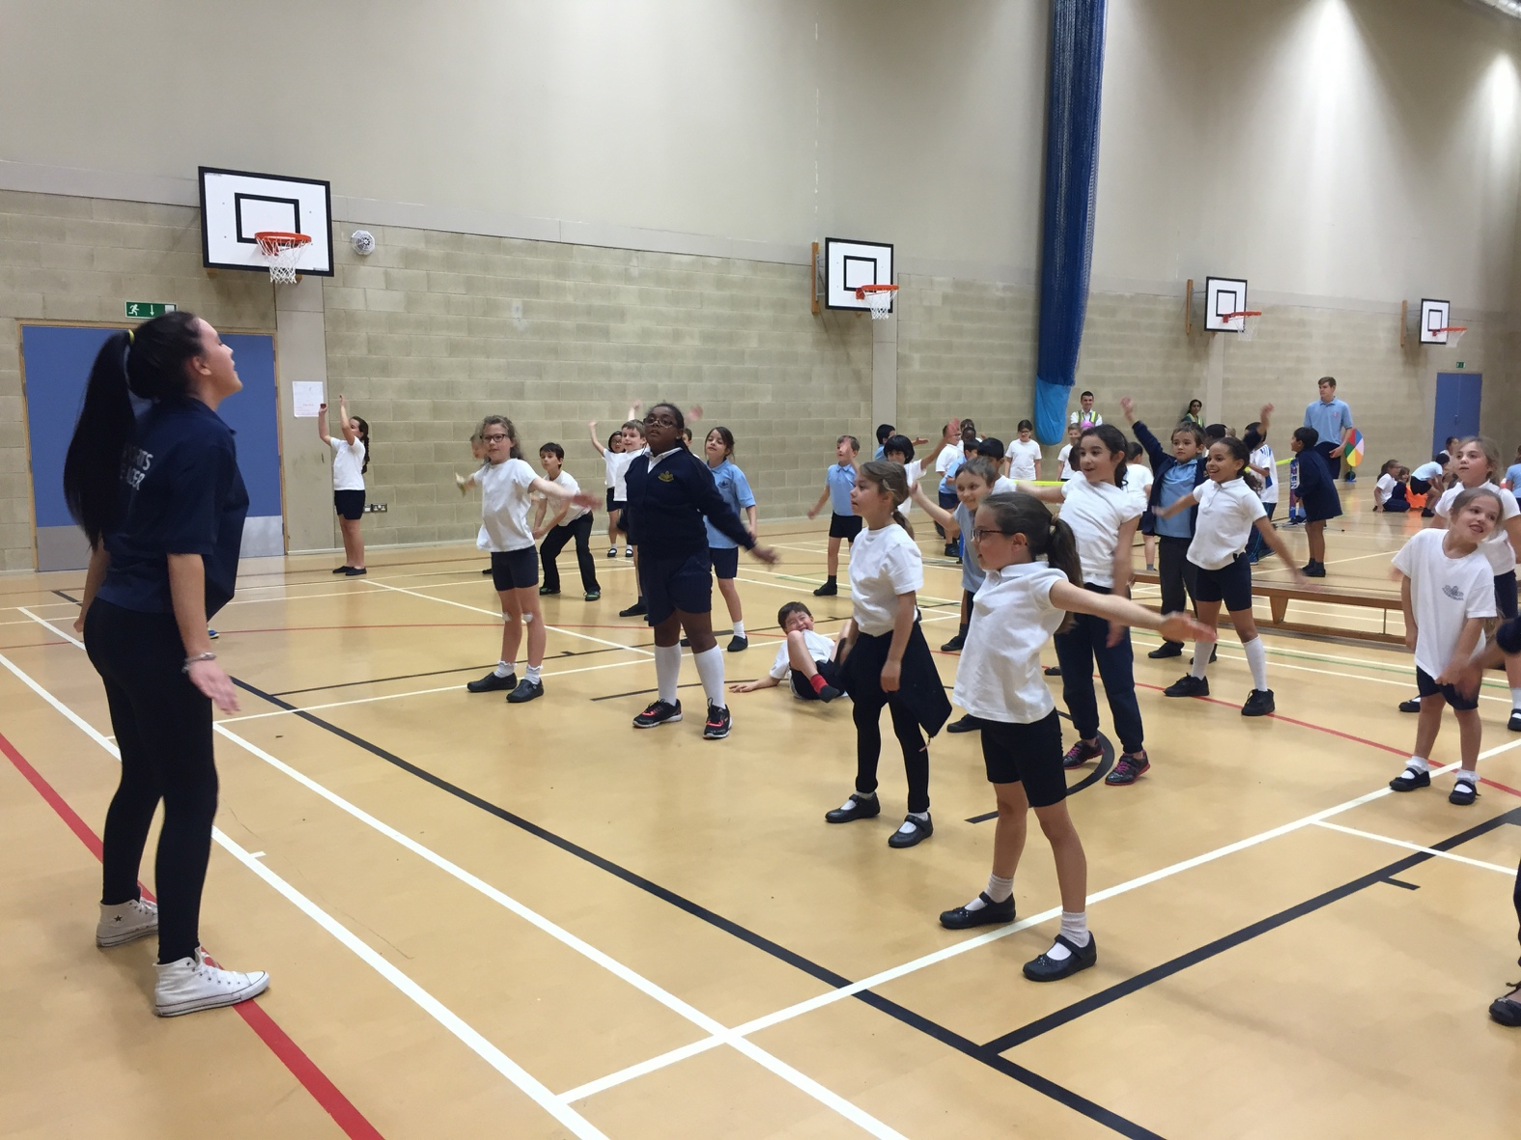

# PE AND HEALTH EDUCATION

We ensure that all children follow a programme of Physical Education and Health in order to promote fitness and health awareness in our pupils. A wide range of sports is played at the school. We run successful football and netball teams and we regularly enter teams in Borough competitions. The sports offered to pupils include football, netball, uni-hoc, kwick-cricket, rounders, swimming and athletics, as well as general PE and gymnastics. We focus upon healthy eating to ensure children understand how best to nourish their bodies.

**MUSIC**

The school has a fine tradition of providing additional musical opportunities for its pupils. We have an Arts Co-ordinator, who is responsible for co-ordinating music throughout the school. Tuition is provided for groups of children learning recorders and many of our pupils from Year 2 upwards benefit from instrumental tuition for woodwind, brass and string instruments. There is a school choir, orchestra and ensemble and musical concerts are a regular feature of school life.

A charge is made for tuition provided by our peripatetic teachers. Such charges may include sheet music, administration costs, insurance and instrument hire.

# SCHOOL JOURNEYS AND EDUCATIONAL VISITS

The school has a history of organising an excellent school journey for Year 6 pupils. This takes place during school time and has a very high educational value. The Year 6 pupils study history, geography and personal and social health education whilst they are away on the trip. The school journey gives great pleasure to those who participate and strengthens the bond between child and teacher.

Regular class educational visits are arranged in conjunction with the major topics studied in each year group. These include visits to such places as museums, art galleries, environmental centres and farms.

These visits are always meticulously prepared. Staff go to the venue beforehand to ensure that the visit will be worthwhile and safe for our pupils.

The year group leader then completes a risk assessment form for the Educational Visits Leader detailing the times, methods of transport, crossing the road junctions, ratio of supervision and food and toilet facilities. When the visit has been agreed, parents/careers are notified of the details.

#### CHARGING AND REMISSIONS POLICY

**Educational Activities Outside Normal School Hours**

1. Charges will be made to cover the cost of all educational activities outside normal school hours, except where: -
2. It is required as part of a prescribed public examination.
3. It is provided to fulfil the statutory duties related to the National Curriculum
4. It fulfils statutory duties relating to Religious Education.
5. Charges can be levied for certain “Optional Extras” out of school hours and, where applicable, the Governing Body will levy appropriate charges on the parents for such items as: -
6. Pupils’ travel costs
7. Pupils’ board and lodging
8. Materials, books, instruments and other equipment
9. Non-teaching staff costs
10. Teaching staff costs, including board and lodging, where staff are specifically engaged for the purpose of providing the chargeable activity
11. Extra curricular “Clubs”.

to cover all relevant costs, but without exceeding the cost of the provision.

**Damage/Loss of School Property**

Damage or loss of school property by pupils is chargeable under legislation and the school will recover, from parents of pupils, the cost of repair or replacement of the damaged or lost property.

#### Additional Materials to Support the Curriculum

Where ingredients or materials are required for areas of the curriculum such as Craft, Science, Design and Technology and Cooking, it is anticipated that they will be used to make an end product, which will then be taken home, or consumed by the pupil in the school. Where these ingredients or materials are not provided by the parents, the school will ask for voluntary contributions to cover the costs. Wherever possible, estimated costs will be given in advance.

BS00559_

## **INSURANCE**

## The School insurance is arranged through the Local Education Authority.

**Reporting to Parents**

A positive and supportive link between home and school can help your child come happily to terms with two very important parts of their life. Your child will learn more readily in the secure and happy environment that such a link can provide. We will keep you informed about your child's progress and of any concerns we might have. Please let us know of any factors at home that might affect your child during the day. It can be difficult to help if we are not clear about the situation. Consultation evenings are held during the year, when parents are invited to talk with staff about their child's progress. An Annual report is sent to the parent/guardian of each child. Arrangements can be made to send copies to both parents if they live at different addresses. Please don't feel that you have to wait for parents' evenings, though! You may make an appointment at any reasonable time, to talk to your child's class teacher or the Head.

**Illness, Absence and Medicines**

If your child is taken ill at school, we will contact you. Children are not allowed to go home on their own if they are unwell. If your child is absent from school through illness, please contact the school office by telephoning before 9 a.m. if possible, or in writing, stating the reason for absence. If your child has to attend a dental or medical appointment during the school day, please give the school the information in writing and arrange for a responsible adult to collect the child at the arranged time or let us know in advance that the child will arrive late on that day. If at all possible arrange these appointments outside the school day. Odd days off taken for "treats" cannot be authorised.

We are able to give medicines to children during the school day. Parents must read and complete a Medical Authorisation form in order for our Pupil Welfare Staff to be able to administer medicines to the children.

If your child is asthmatic, diabetic, extremely allergic or has epilepsy, please let us have all the relevant information and emergency or preventative treatment in school.

****

**School Health Service**

During your child's first term at school, s/he will be offered a general health check, including a measurement of height and weight and a hearing test. These are carried out by the School Nurse. At some time during their first year at school, your child will have a vision test, carried out by an Orthoptist. Dental screening is carried out every year. The School Health Service now operates a system of selective medicals. During their first year at school, children are considered for a medical if concerns have been raised by parents, the School Nurse or the school. In all cases, you will be asked to give consent to the medical and will be invited to attend. If you have any concerns about medical matters including bedwetting, soiling and behaviour at home, you can contact the School Nurse who will be happy to discuss your concerns with you and offer help as appropriate. For contact details, please ask at the school office.

**Food and Drink**

The school serves good quality dinners, which are planned to provide a balanced and healthy diet with a choice of food every day. The cost is payable on a daily/weekly/termly basis but must be in credit at all time. If you think your child may be entitled to free school meals, collect an application form from the school office. The cost of school meals is £2.30 a day. Children can also bring a packed lunch from home for lunch. Our School menu is attached for your information.

Free School Milk is available on a termly basis for Foundation Stage children.

Snacks and Sweets are not allowed in school. Fruit is allowed at break time.

Drinks for the children should not be in glass containers or cans, for safety reasons. No carbonated drinks, please. Fresh water is always available for children. Children may also bring a bottle of water for drinking at playtime or a bottle in which to store water for during the school day.

**School Uniform**

We have the following recommended uniform:

• navy skirt or pinafore, navy or grey trousers;

• white or sky blue shirt/polo shirt or blouse;

• white or navy socks or tights;

• blue gingham dress (summer).

Flat, black, comfortable shoes (but not trainers) should be worn.

Clothing worn for medical, religious or cultural reasons is also

acceptable in the correct school colours.

School sweatshirts and T-shirts are available from the school office

and also on the last induction afternoon before your child starts school.

For P.E., children need navy shorts, white T-shirt and black plimsolls. Trainers can be worn for outdoor PE. These are best kept in a traditional drawstring II pump bag ". If you have concerns about this for religious or cultural reasons, please come and talk to the Head.

**Jewellery**

The wearing of jewellery is inappropriate for school. If children wear earrings, they must be plain, small studs, for safety reasons. Even these will have to be removed or covered with tape for PE. Jewellery may be worn for religious or cultural reasons, with appropriate safety precautions.

**Concerts**

It is a tradition at Danegrove that all children take a full part in our assemblies, concerts, shows and the like. Shows and Concerts are not religious in content which enables children of all religions to enjoy the experiences provided by dramatic productions.

**Caring for our Environment**

We have:

• a paper recycling scheme;

• a gardening/pond area for the preservation and study of wildlife;

• a commitment to develop environmental education over the coming year.

**Parents with Disabilities**

If there is any way in which we can help you to enter fully into the life of the school or to access information about your child, please let us know. The front entrances are ramped and the school is accessible internally, with a toilet for the disabled. We can easily arrange for large print information, easy access, seating for events etc., and would be happy to help in any way we can.

**Translation Service**

We are pleased to be able to arrange for interpreters and/or translation of any school document. Please contact us to arrange this.

## **BREAKFAST CLUB and AFTERSCHOOL PLAYSCHEME**

Danegrove has a Breakfast Club and Afterschool Playscheme that operates daily during term time, and is available to all pupils at the school.

The Breakfast Club provides supervision for children from 7.30am until school begins. Children receive a breakfast and activities are provided.

The afterschool Playscheme runs from the end of school until 6pm. On arrival children are provided with a snack and drink. They are able to take part in a variety of practical activities from football, cooking, craftwork and board games and homework completion for the older children.

These facilities have proved a popular attraction for many parents to use on either a regular or occasional basis.

After school the children are registered then have lots of different free play activities to choose from. Drinks and snacks are provided.  We are open until 6:00pm every school day.

We also offer a fun packed Holiday Scheme throughout the summer break, Easter break, at half terms and the first part of Christmas.

A full price list is available from the office or directly from playscheme.

Quotes from the children:

"The best part about coming to breakfast club is toast"

 "My favourite part of breakfast club is butter and honey on toast"

 "I like it when I get to play football at after school club"

 "I like reading the Guinness World Record book with my friends"

 "I love the bouncy hoppers"

 "Kylo is the best thing about after school club"

 "It's nice because all of my friends are here"

**Who’s Who at Danegove School** 

   

Linda Gowling John Ireton Janet Mead Peggy Salmon Robert Russell

Chair of Governors Vice Chair Safeguarding/ Community Staff Governor

Health & Safety Governor

  

Deborah Metcalf Nick Davis Huseyin Huseyin

Headteacher Deputy Head Deputy Head

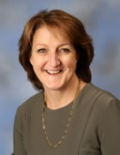  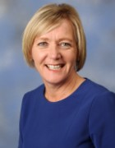

Alison Moretti Nigel Doe Joanne Manvell

Business Manager & Bursar Administrative Assistant

Leadership Team

**Who is Who**

**Leadership Team September 2019**

|  |  |
| --- | --- |
| **Headteacher**  **Leader on Assessment and**  **Governor Liaison**  Deborah Metcalf  (Teacher Absence)  **Deputy Headteacher**  Huseyin Huseyin  Leader of Learning Focus: Literacy  (TA Absence Yrs 3, 4, 5, 6)  **RE & Art Lead**  Sally Giovanelli  **SENCO**  Jo Campion  **ICT Lead**  Lilly Charidemou  **PE LEAD**  Nick McKellow  **Bursar**  Nigel Doe  **Chair of Governors**  Linda Gowling  **LEA & Community Governors**  Cllr Pauline Coakley-Webb  Linda Gowling  Peggy Salmon  Janet Mead  John Ireton – Vice Chair  Robert Russell  Nick Davis  Huseyin Huseyin  Kristel Stevens  **Staff Governors**  Deborah Metcalf | **Business Manager**  Alison Moretti  (MTS, Catering & Caretaking Absence)  **Clerk to Governors**  **Deputy Headteacher**  Nick Davis  Leader of Learning Focus: Numeracy  (TA Absence F/S, Yrs 1 & 2)  **Assistant Headteacher**  **Site Leader, Foundation Stage**  **and Yr Gp 1 Lead**  Ridgeway Avenue  Elena Toumazou  Standards and Attainment FS & KS1  **Values &**  **PSHE Lead**  Joanne Suarez  **Yr Gp 2 & Science Lead**  Robert Russell  **Yr Gp 3 Lead**  Cheryl Baptiste  **Yr Gp 4, Dance & EMA Lead**  Farrah Ghosseiri  **Yr Gp 5 & Integrated Studies Lead**  Leah Grogran  **Yr Gp 6 & Music Lead**  Catherine Gallantine  **Parent Governors**  Simon Moore  Alex Gilbert  Mukharram Mirbabaeva  Anna Nemchinova  Lillian Pang  Maria Allan |

**Danegrove School Staff – September 2019**

|  |  |  |
| --- | --- | --- |
| **Year Group** | **Teachers** | **Teaching Assistants** |
| Foundation Stage | Joanne Suarez, Nicola Jones, Emily Matthews | **Downs Team – Lead Rae D’Silva**  Kat Mouskoundi, Arlette Wendersen, Jasmine Lacsamane, Yasmin Geeves.  **Autism Lead – Lead Joanne Hughes**  Ceyda Murat, Fiona Neville, Joanne Woodland, Tatiana Zarifi, Bianca Danculea, Leuretta Shebu, Sharon Gayfer, Suzanne McKenzie-Cook, Helen Bhatty, Carolyn McNeil, Sarah Dabiri, Clare Bell, Quan Lam, Stefania Teshome, Alison Weekes, Sibel Hassan, Rae D’Silva.  **Interventions/SEN Plans**  Nicola McArdle, Angela Kilminster, Lefki Efstathiou, Rae D’Silva, Jacqui Pinchess, Helen Bhatty, Sandie Bazell, Louise Green, Sibel Hassan, Stefania Teshome, Hayley Down, Sue Tibbs & Jo Martindale. |
| Year 1 | Elena Toumazou, Sally Giovanelli, Alice Ioannou, Georgina Turner |
| Year 2 | Robert Russell, Yasmin Ahmed |
| Year 3 | Sam Cowan, Cheryl Baptiste, Sophie Issimdar |
| Year 4 | Farrah Ghosseiri , Freddie Rolle, Rachel Vald |
| Year 5 | Leah Grogan, Lisa Beskeen, Fiona Henderson, Jaweria Alam |
| Year 6 | Catherine Gallantine, John Forrest, Matt Langley |
| PPA Staff | Nick McKellow, Sara Del Rio Perio, Sally Giovanelli, Zohreh Mahmoudi | |
| ICT Lead | Lilly Charidemou | |
| Admin Staff | Nigel Doe, Joanne Manvell, Julia Stokes | |
| Learning Mentor | Kristel Stevens | |
| Caretaking Staff | Gary Stevens, Mark Goodbody | |
| Welfare Staff | Susan Shepherd, Wendy Wilson, Tosh Murat, Sandie Bazell | |
| Playscheme Staff | Deborah O’Connor, Kylo Kelly, James Ansell, Hannah Ansell, Annabel Shepherd, Charles Haydock, Harry Haydock, Lewis Weeks. | |
| Catering Staff | Angela Kidd, Marie Wilson, Anna Bennett, Sue Little, Bridgette Martin, Lynsey Ball, Kerrie Tripp, Diana Popova, Gill Arasan | |
| Mealtime Supervisors | Janice Dumont, Julie Smith, Kat Mouskoundi, Nicola McArdle, Yasmin Mohammed, Andri Ellinas, Louise Green, Cheryl West, Katie Brown, Natalie Butterworth, Suzanne McKenzie-Cook, Dee Halil | |
| Cleaning Staff | Diana Popova, Iwona Rokszewska, Sabrie Selimova, Valka Staykova, Cheryl Gullon, Katie Brown | |
| Late Officers | Julia Stokes | |

PE03254_

**Admissions – Reception to Year 6**

**To apply for a place at Danegrove School you must contact Barnet Council. The council handles all admissions and will be able to give you information on the cut off dates for applications.**

Danegrove is a Community school and is therefore owned and funded by Barnet Council. The admissions criteria are set and applied by the local authority. Please read further down this page for the admission criteria for Danegrove.

Applications for Nursery are made direct to the school.

Applications for Reception to Year 6 are made through Barnet. [www.barnet.gov.uk](http://www.barnet.gov.uk)

The main point of entry to the school is in Reception. Legally a child must be attending school the term after their fifth birthday. Almost all children in Barnet start school before they are five.

All London boroughs work together on the Reception class admissions process and this is known as the Pan-London co‑ordinated admissions scheme.

As part of the scheme:

* Parents can apply for up to six schools
* The application is made to the local authority where you live
* If a school is oversubscribed, its published admissions criteria is used to decide who should be offered a place
* The scheme makes sure that no child is offered more than one school place
* Your home local authority will post you the result of your application

If you live in Barnet you must apply using a Barnet Common Application Form (CAF), where possible online.

As part of the application, you will need to send Barnet two items as proof of your address (photocopies please). These can be: a child benefit letter or tax credit documentation, and a copy of this year’s Council Tax bill.

If your address has changed in the last two years, you may be asked for further proof that your current address is your permanent home address.

When parents live separately, the application must be based on the address at which the child usually lives and from which s/he attends nursery school. When parents live separately but the child lives with both parents at different addresses, the child’s home address will be taken to be the address where the child lives for most of the week. If the child spends an equal amount of time with each parent, the address will be taken to be that of the main parent/carer eligible to receive Child Benefit and Child Tax Credit.

When all the applications have been considered: admission lists will be drawn up for all schools.

In mid-April a letter will be sent to you by first class post to let you know the result of your application.

If you applied online, you will be sent an email with the outcome of your application.

**In 2019 Danegrove offered 90 places. There were in total 210 applications for the school. Twenty two of the places went to siblings. No places were offered to children outside our defined area.**

A map of each community school’s priority area can be viewed at www.barnet. gov.uk/schools. Or you can call the Admissions Team on 020 8359 7651 to obtain a copy. Living in a priority area does not guarantee a school place.

Unless otherwise stated distances are measured between the address point for the child’s home, supplied by the Post Office, and the main school.

**Admission Criteria for Danegrove School**

**If there are more applications than the number of places available, places will be offered according to the following order of priority:**

* Children who are ‘looked after’ and children who were adopted (or subject to residence orders or special guardianship orders) immediately following having been ‘looked after’. A child looked after is a child in the care of a local authority or provided with accommodation by that authority in accordance with Section 22 of the Children Act 1989. An adopted child is defined by section 46 of the Adoption and Children Act 2002. A residence order is defined by section 8 of the Children Act 1989. A special guardianship order is defined by section 14A of the Children Act 1989.
* Other children whom the Director of Education and Skills accepts have an exceptional medical, social or other need that the school is particularly able to meet. Applications in this category will be considered only if they are supported by an attached written statement from a doctor, social worker or other appropriate professional. Parents must demonstrate that there is a very specific connection between the child’s need and the particular school. Difficulties with child care arrangements because of work or other commitments would not be grounds for priority under this category. Information not provided at the time the application is submitted may not be considered at a later date.
* Children who, at the time of admission, have a sibling (brother or sister) living at the same address who already attends the school, or the linked school in the case of separate infant and junior schools. Siblings would include half, step, adoptive and foster siblings provided they also live at the same address as the applicant.
* Children living within the individual school’s defined area, with priority given to those who live closest to the school when measuring distance in a straight line.

Unless otherwise stated distances are measured from the address point for the child’s home, supplied by the Post Office, to the school’s main gate. The distance between these points is calculated using the Council’s computerised geographical information system.

Tie Breaker – distance will be used as a tie-breaker within each category.

Final Tie Breaker – applicants from the same block of flats, or applicants who live the same distance from the school will be selected in random order and places will be offered accordingly.

Applications made on behalf of twins or triplets – if only one place is available at the school and the next child who qualifies for a place is one of multiple birth siblings, we will ask community schools to go over their published admission number to support the family. These children will be deemed as ‘excepted’ pupils under infant class size legislation.



**From Little Acorns …**

**Mighty Oaks Grow**