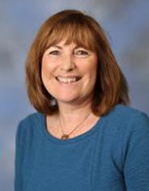
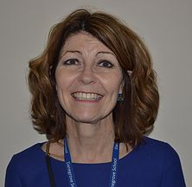
Danegrove Primary School!

Myself, Ivana and my friends Yasmin and Melissa decided to interview Mrs Metcalf and Mrs Gunning on Friday 5th February 2016 and put it on the school website!
Children are very lucky to have Mrs Metcalf and Mrs Gunning as Head/Deputy Teachers in Danegrove Primary School because they are caring and they treat us like their own children! They’ve always been there for us through thick and thin. They make sure that we’re safe and they encourage us to always work hard and never give up! Their first impression of the school was that it looked like a place where children enjoyed learning and felt safe. Mrs Metcalf and Mrs Gunning say that to be a good head/deputy teacher is to first learn how to be a teacher and then start improving and become a head/deputy teacher.
We asked Mrs Metcalf and Mrs Gunning what their favourite thing about the school and they chose – the kids, the staff, the learning , the fact that we all come from around the world , school dinners and the school values.
As you can see this has told you that Danegrove Primary School is a caring place for your children!
Call 02084494024 to find out more information!

