Hi everyone in Year 2,
Hope you are all well and keeping safe and healthy! Let’s get on with another day of fun learning!
Make sure you get your daily exercise in by tuning into ‘The Body Coach’ at https://www.thebodycoach.com/blog/pe-with-joe-1254.html.
How did you go with yesterday’s riddle? Hope it make you think! At the end of this sheet, I have put another riddle for you to work out! The answer for it will be in tomorrow’s answers!
Literacy (1 hour): SPAG: Use the conjunction poster from yesterday’s work to recap on the types of conjunctions.
Use conjunctions to fill the gaps in the sentences below:
- I like going to the park ___ having fun on the swings.
- I tried to run as fast as I could ___ I still came last in the race.
- I went to bed early ____ I was really tired.
- The final score was 1-0 __ I think their goal was not fair.
- My Dad said that he would take me to the trampoline park ___ I got a merit at school.
Main: Re-watch ‘Whatever Next’ by Jill Murphy. https://www.youtube.com/watch?v=Nn73STXrPP0
From your story map from Monday and the answers from the comprehension on Tuesday, you should have a good understanding of the story. The order of the comprehension questions follows the order of the story so use that to help you. If you need reminding, watch the video again. On Wednesday, you created a character profile for your own two characters. You are going to use your own characters and write your own version of the story.
Today you will write the beginning and middle part. Here are some ideas for what the beginning and middle can include. Please add your own ideas too!
Beginning:
- A good story opener – One sunny day, On a quiet night, Once upon a time
- Introduce the main character (this will be the one you created) with descriptions (expanded noun phrases).
- Where he/she lives, who they live with, what does he/she have to do with Mummy Bear (bath time, homework, shopping)
- What your character finds under the stairs – space helmet/space boots/jacket/backpack/food/teddy/lucky charm.
Middle:
- What does your character see when they fly off in the rocket: clouds/plane/mountains/the ocean. Who they meet on the way to the moon (this will be the other character you created).
- What do they do on the moon? Have a picnic, play a game (hide and seek, tag), paint a picture or create a drawing, make music and sing or dance.
Extension:
Think of a different ending for the story. What does Mummy say to your character when he/she returns? Why does your character leave the moon and go home or go somewhere else after? Do they meet someone on the way back?

Numeracy: Column Addition: With exchange
Watch the video in the link below of Mr Davis explaining how to use exchanging in column addition. https://www.youtube.com/watch?v=yxP_DJla7Tc&list=PLxyUJEC5mlQ7VJ7eXFC-dXqHmhg6NsXXO&index=7&t=0s
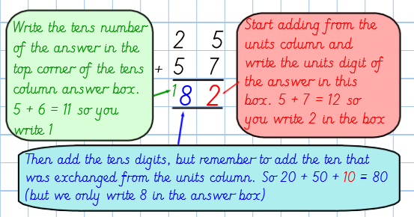
Example and explanation:

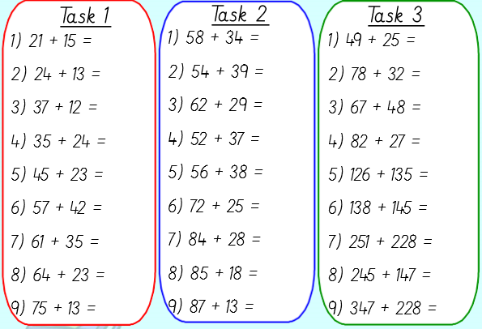
Choose a task and complete the tasks that you are comfortable with. Task 1 has no exchanging and Task 2 and 3 is with exchanging.
Extension: Create 5 of your own column addition sums.
Spanish – Hola! It’s time to catch up on some Spanish!
This is the Spanish song of the week:
https://www.youtube.com/watch?v=ZiNFXntWOJw
With it you will learn numbers up to ten and the different colours, but we will focus on the colours this week.
Task 1: Listen to the song a few times to remember the colours in Spanish. (Maybe you can perform the song in front of adults or teddies at home)
Task 2: Draw a picture of your favourite hobby and afterwards, write in Spanish all the colours you used to make it.
We need to practice our “Spanish Listening” to be able to understand everybody. Your challenge is: Listen to this song and try to hear all he words that you already know in Spanish. You can also read the subtitles to try to find more words to learn!
https://www.youtube.com/watch?v=wEStDVt5s1E (Colores en el viento, Pocahontas)
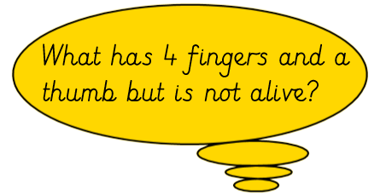
Ready for the Riddle?

(No searching on the internet for the answer or asking an adult!) The answer to this riddle will be in tomorrow’s answer sheet.

Hope everyone had a great day, answers tomorrow. And remember to check out our ‘Useful websites’ button for more learning opportunities. Bye!
Team Year 2

