Hi everyone in Year 2,
Happy Hump Day! Hope you’ve all had a good rest and are ready for another day of learning!
Make sure you get your daily exercise in by tuning into ‘The Body Coach’ at https://www.thebodycoach.com/blog/pe-with-joe-1254.html.
At the end of this sheet, I have put a fun riddle for you to work out! The answer for it will be in tomorrow’s answers!
Literacy (1 hour):
SPAG: Proper Nouns: Proper nouns are names used for an individual person, country or city, day of the week or month and organisations. They always begin with a capital letter. Identify the proper nouns in the sentences below and correct them by adding a capital letter in the correct place.
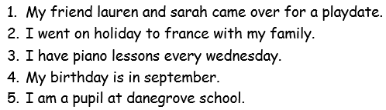
Main: Re-watch ‘Whatever Next’ by Jill Murphy. https://www.youtube.com/watch?v=Nn73STXrPP0
This time, focus on the character of Baby Bear and Owl and think of some words to describe them (adjectives).
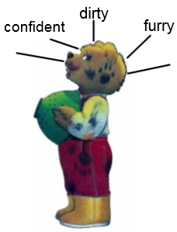
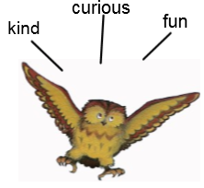
(10-15 min) Draw a picture of Bear Bear and Owl on separate sheets and label them with adjectives to describe them. E.g.
(15-20 min) Now think of 2 characters of your own and
draw a character description of them.
Main Character - Baby Bear could be: Lion, Baby Badger, Baby Pony
Owl could be: Eagle, Pigeon, Robin, Dove, Magpie, Crow, Raven, Wood pecker
Extension:
Where does your main character live and what is their family like?

Numeracy: Column Addition: With exchange
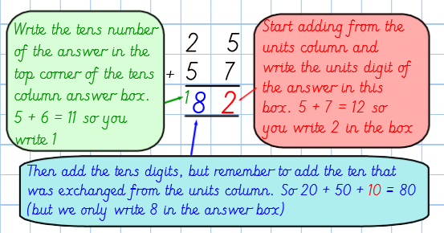
Watch the video in the link below of Mr Davis explaining how to use exchanging in column addition. The video explains how to do this using the dienes but you will need to follow his written method when writing your sums. https://www.youtube.com/watch?v=yxP_DJla7Tc&list=PLxyUJEC5mlQ7VJ7eXFC-dXqHmhg6NsXXO&index=7&t=0s
Example and explanation:

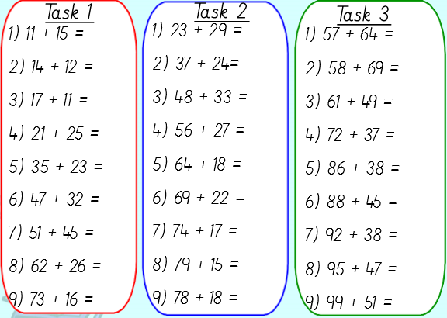
Choose a task and complete the tasks that you are comfortable with. Task 1 has no exchanging and Task 2 and 3 is with exchanging.
Extension: Create 5 of your own column addition sums.

D&T – Designing a Rocket (hopefully you have collected some junk modelling so you can make your rocket!)
Using your design from yesterday, you can now begin to make your rocket. Try and stick to your design but if you need to make changes and your rocket is not exactly like your design, it’s ok and just edit your design to suit your rocket. Get creative and see what junk material you can use around your house.
If you are using scissors, please be careful and ask an adult if you need help.
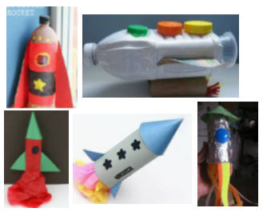
Have fun and I know that your rockets will be out of this world!

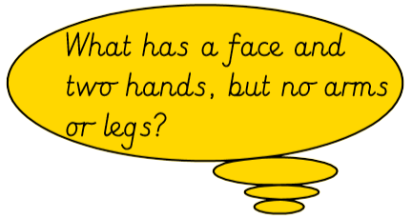
Ready for the Riddle?

(No searching on the internet for the answer or asking an adult!) The answer to this riddle will be in tomorrow’s answer sheet.
Hope everyone had a great day, answers tomorrow. And remember to check out our ‘Useful websites’ button for more learning opportunities. See you later, alligators!!
Team Year 2

